**PROBLEM STATEMENT:**

Create a class string with required data members and member functions. Use the concept of operator overloading to compare two strings using ‘>’, concatenate two strings using ‘+’, extract the second string from the first, if at all it is a substring of the first string (use ‘-‘ ).

**PROGRAM CODE:**

#include<iostream.h>

#include<conio.h>

#include<string.h>

class str

{

private:

char name[50];

public:

void enter()

{

gets(name);

}

void disp()

{

puts(name);

}

str operator+(str x)

{

str temp;

strcpy(temp.name,name);

strcat(temp.name,x.name);

return temp;

}

int operator>(str x)

{

int n=strcmp(name,x.name);

return n;

}

void operator-(str x)

{

int flag=0,i,j,k;

for(i=0;i<strlen(name);i++)

{

if(name[i]==x.name[0])

{

flag=1;

for(j=0;j<strlen(x.name);j++)

{

if(name[i+j]!=x.name[j])

{

flag=0;

break;

}

}

if(flag==1)

break;

}

}

if(flag==1)

{

cout<<"\nThe substring is: ";

for(k=i;k<(i+strlen(x.name));k++)

cout<<name[k];

cout<<endl;

}

if(flag==0)

cout<<"\nString 2 is not a substring of String 1\n";

return;

}

};

int main()

{

str s1,s2,s3;

int ch,n;

cout<<"Enter String 1: ";

s1.enter();

cout<<"Enter String 2: ";

s2.enter();

a:

cout<<"\nChoose:\n1. Compare\n2. Concatenate\n3. Extract a substring\n4. Exit\n";

cin>>ch;

switch(ch)

{

case 1:

n=s1>s2;

if(n>0)

cout<<"\nString 1 is superior\n";

else if(n==0)

cout<<"\nBoth strings are equal\n";

else

cout<<"\nString 2 is superior\n";

getch();

goto a;

case 2:

s3=s1+s2;

cout<<"\nThe concatenated string is: ";

s3.disp();

getch();

goto a;

case 3:

s1-s2;

getch();

goto a;

case 4:

break;

default:

cout<<"\nEnter a valid choice\n";

goto a;

}

return 0;

}

**OUTPUT:**

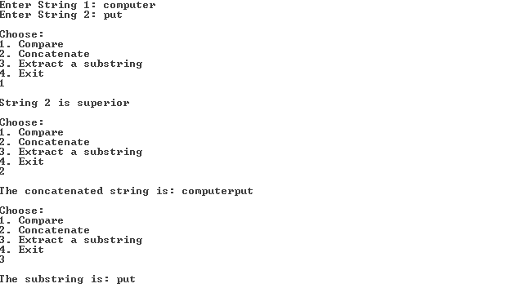

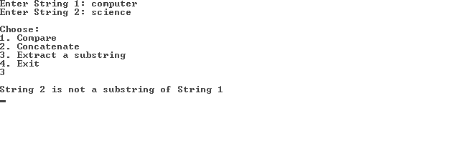

**RESULT:**

This program employs operator overloading to compare two strings, concatenate them and extract a substring (second string) from the first string.